-------------------------------------------------------------------------------------------------------------------------------NAME: ARCHANA DEVI.P
REG NO: 192521192
COURSE: SOFTWARE TESTING
CODE: CSA0923
LAB PROGRAMS
Question 25: Calculate a Student's Grade Using Functions and JUnit

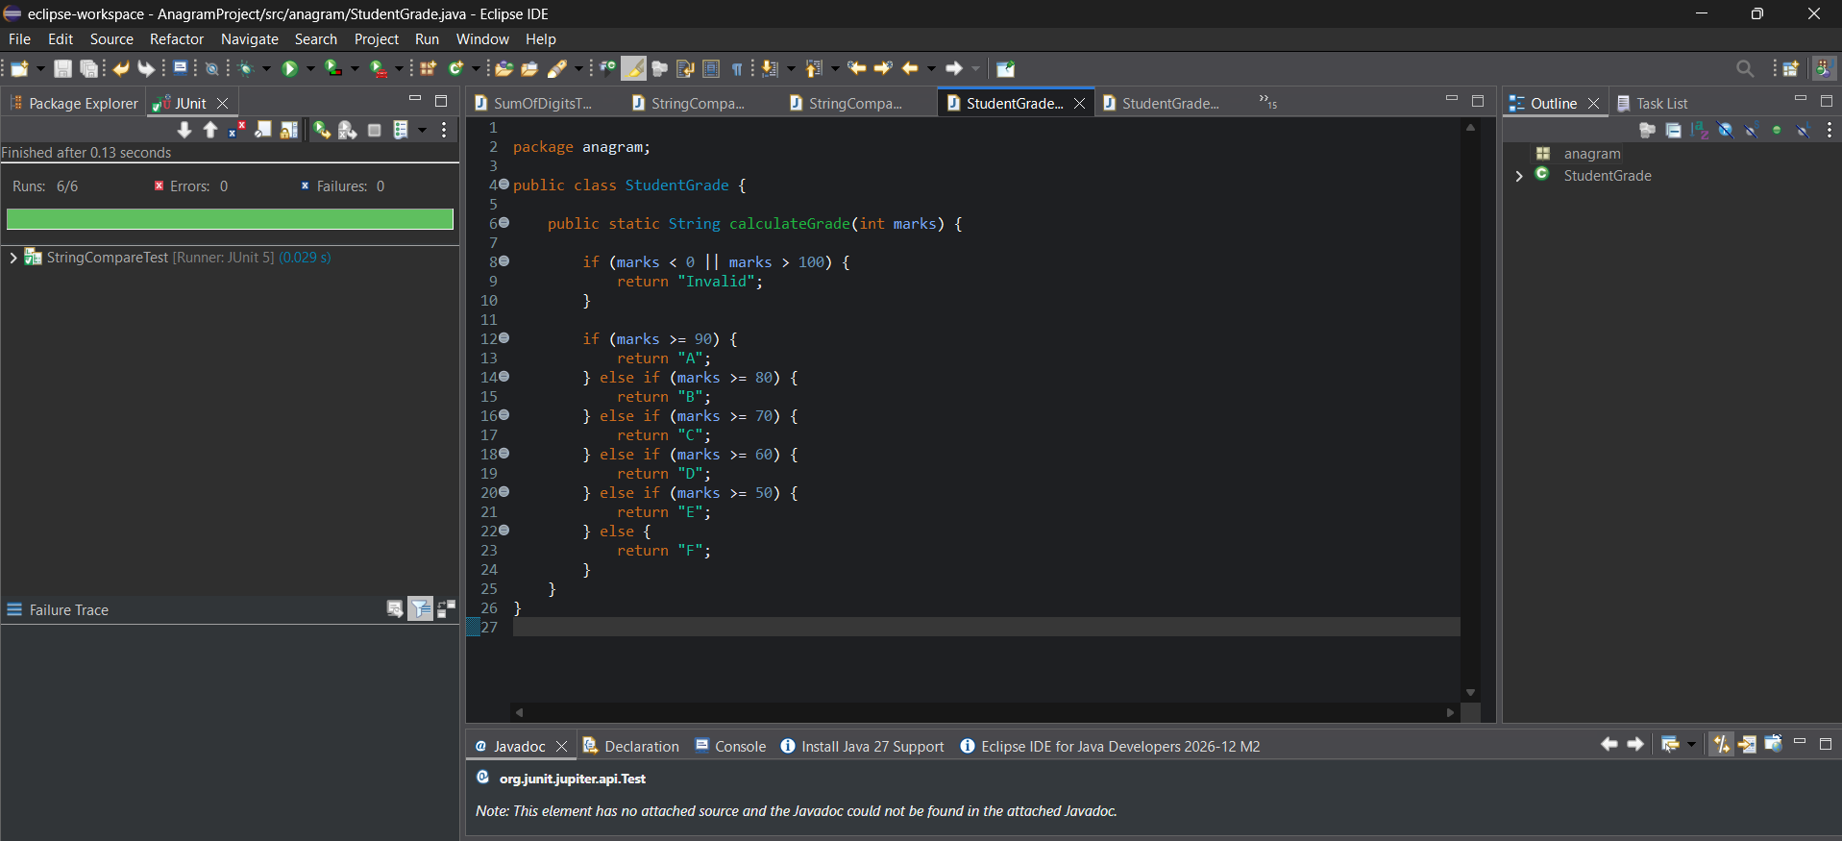

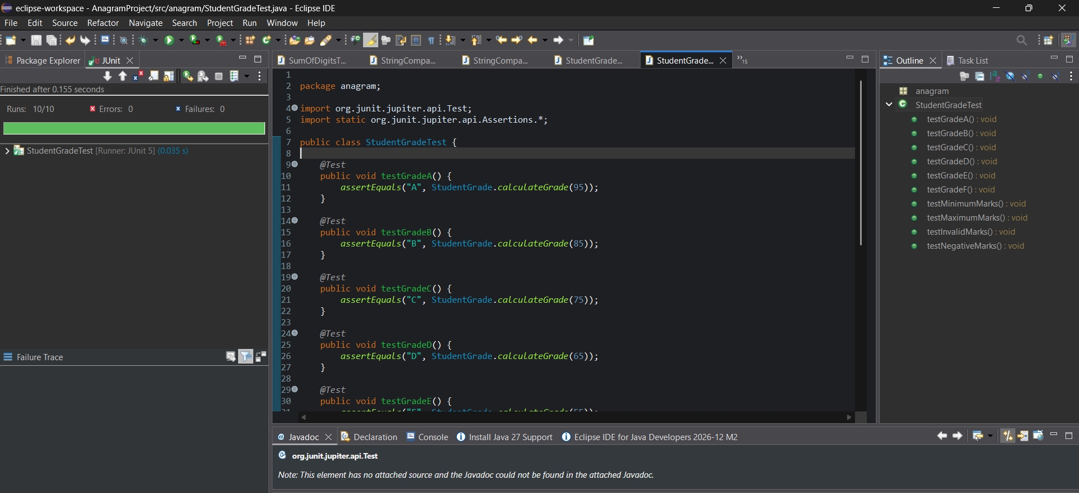
White-box testing
The test cases cover each grade condition and the invalid-input condition:
- Grade A, B, C, D, E, and F.
- Minimum valid mark (0).
- Maximum valid mark (100).
- Marks above 100.
- Negative marks.
This helps verify that each conditional branch returns the correct grade.
Result: The student grading program was implemented using a Java function and validated using JUnit 5. Ten test cases cover the grade conditions, boundary values, and invalid inputs.

